# **Objective**

Design and develop a simplified, user-friendly return management system for Leviotto's B2B footwear business.

The system must allow users to process product returns from multiple sales orders and generate a single credit note, without linking directly to original deliveries.

# **Required Configuration**

## **User Access Configuration**

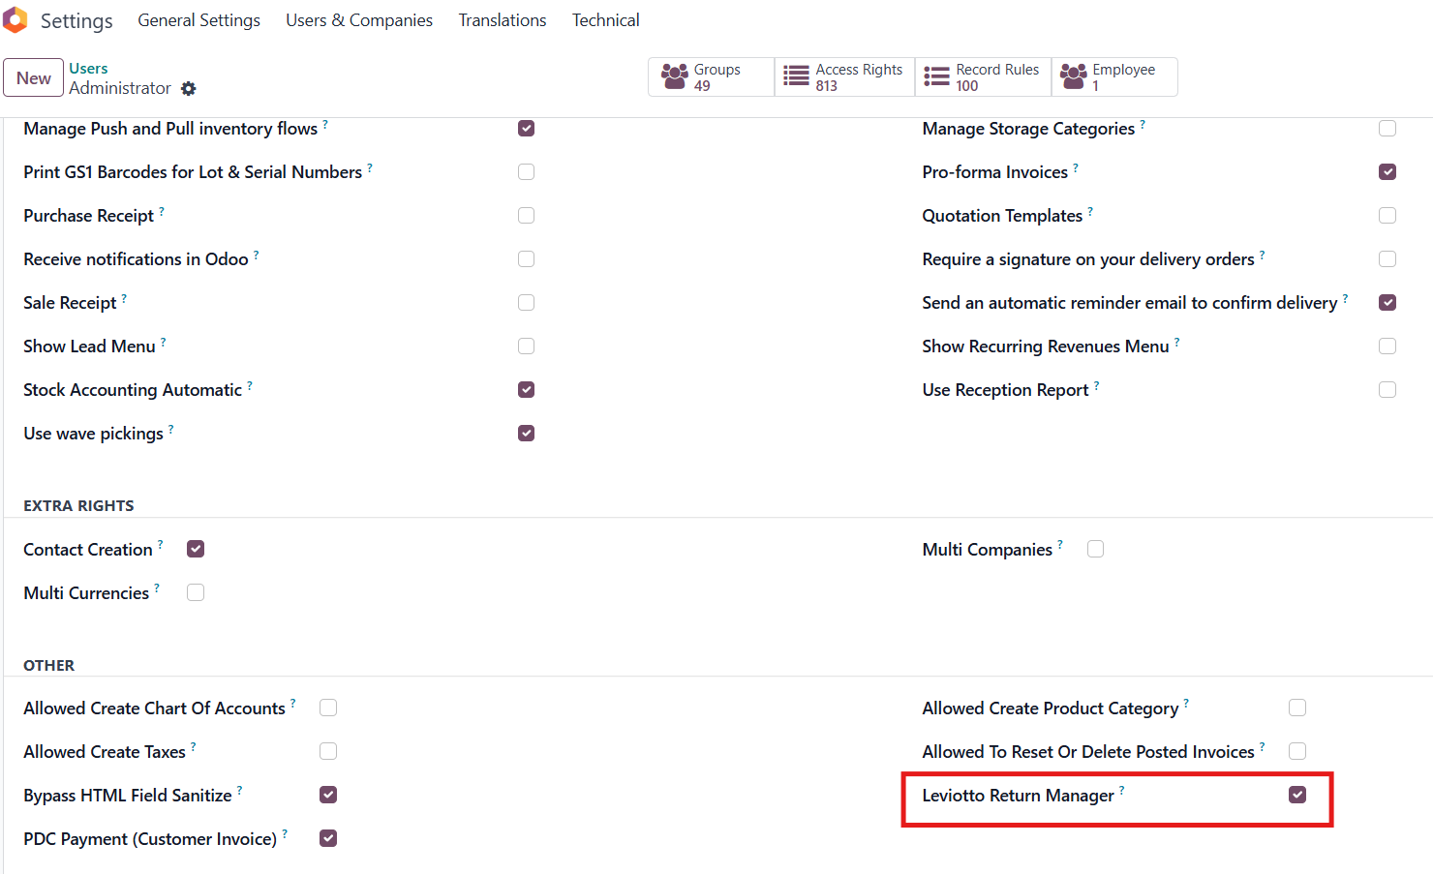

Only users with the **"Leviotto Return Manager"** permission can create return sales orders.

* Go to user settings.
* Enable the **"Leviotto Return Manager"** permission for the appropriate users.

## **Operation Type Configuration**

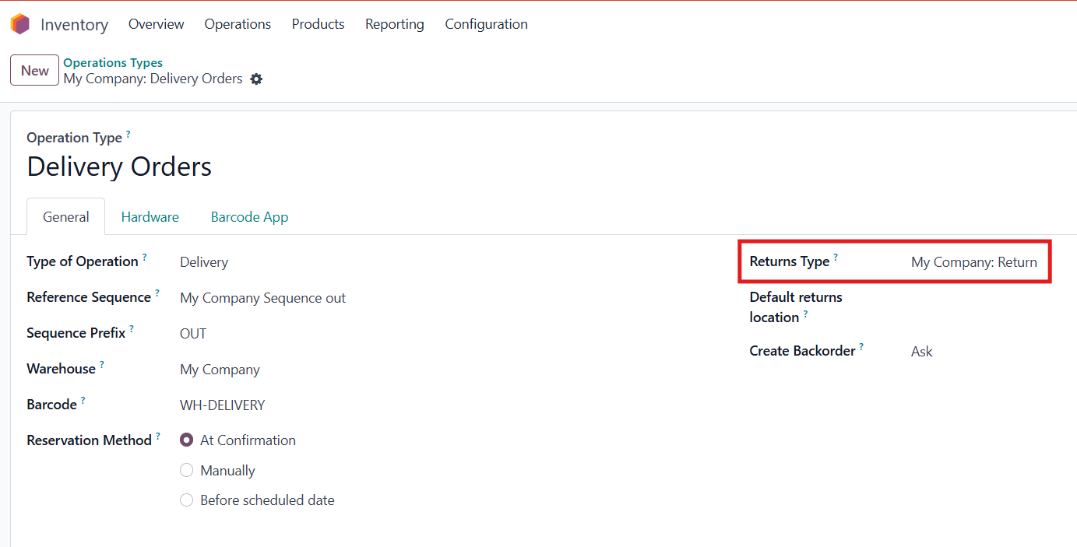

Set the return type **Return** in Delivery orders Operation type.

This configuration will be used to generate the **return picking**.

## **Sales Order Configuration**

Ensure the following settings are applied

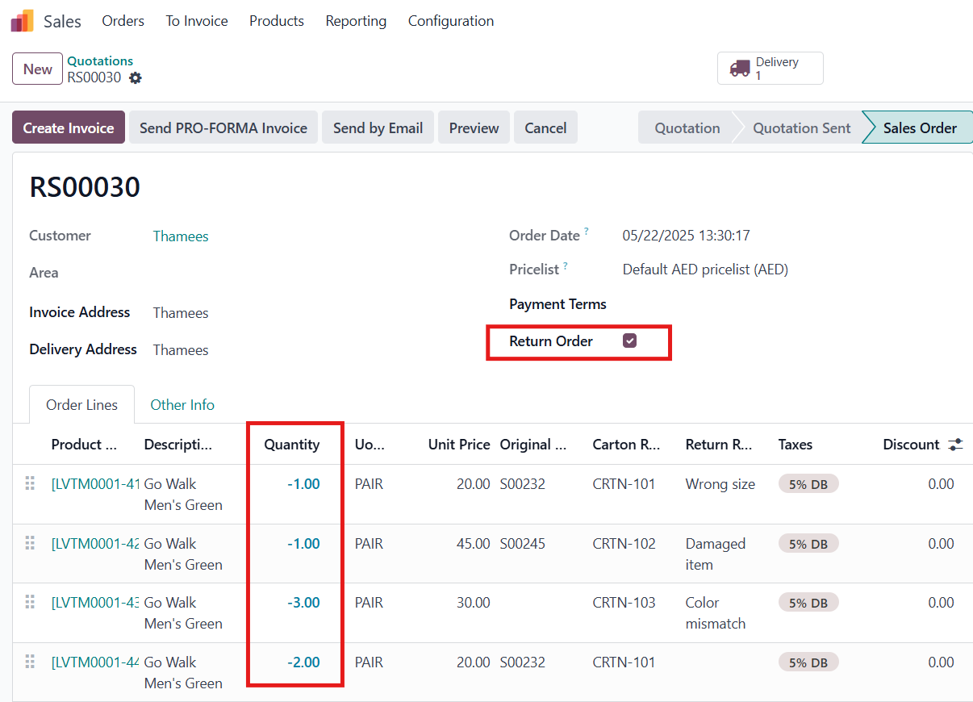

**"Return Order"** checkbox must be enabled in the sales order.

**Product quantity** must be negative to indicate returned products.

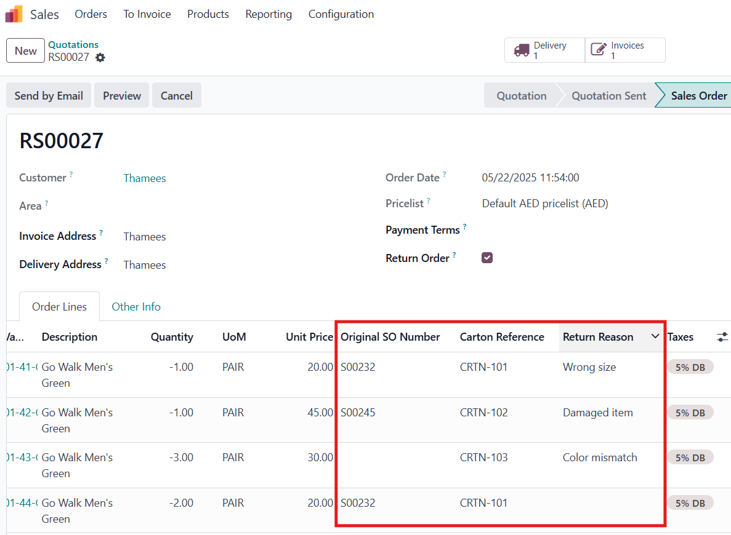

Optional Fields (Displayed in Invoice as well):

* **Original SO Number**: Reference to the original sales order.
* **Carton Reference**: Identifier for the returned carton.
* **Return Reason**: Explanation or reason for the return.

# **Generate a Return Delivery**

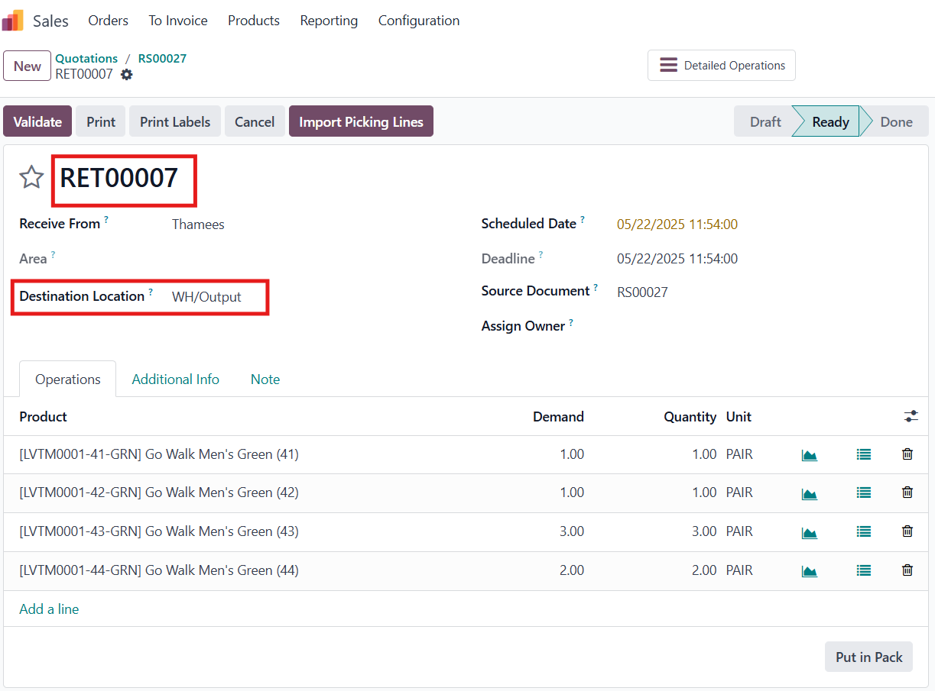

Automatically generated when the return sales order is **confirmed**.  
Stock movement reflects a **negative delivery** (goods returned to the warehouse).  
**Destination location** is automatically set based on the Operation Type configuration.

# **Create Credit Note (Invoice)**

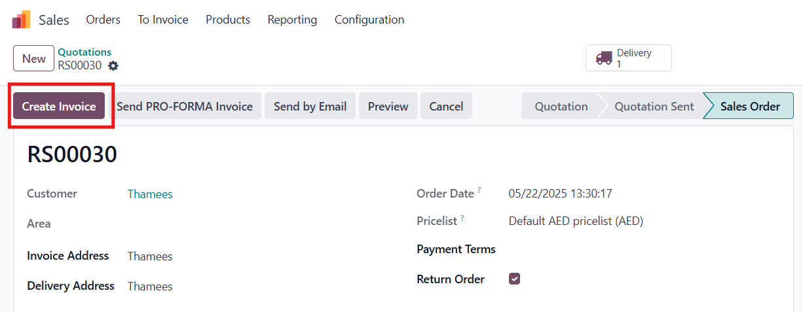

Click **"Create Invoice"** in the sales order to generate the credit note.

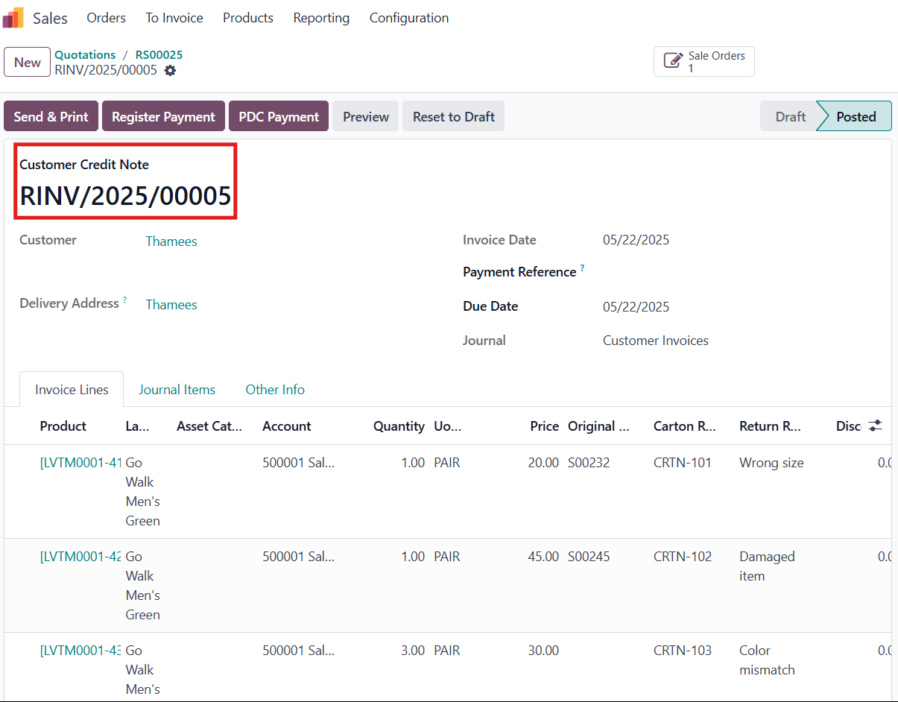The credit note will include Original SO Number, Carton Reference, Return Reason

# **New Menus in Sales**

## **Return Orders**

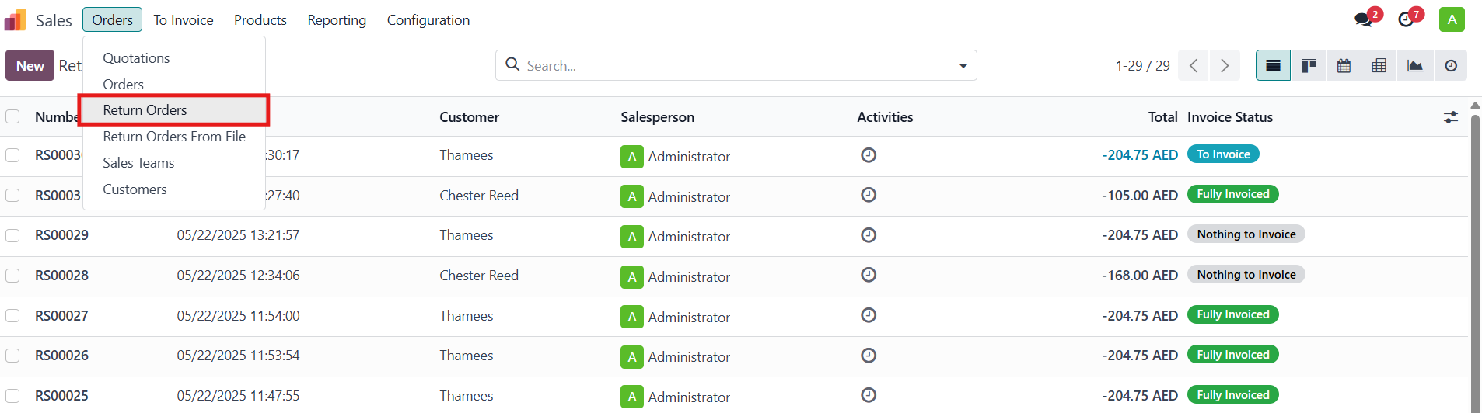Lists only return sales orders for easier management.

## **Return Order from File**

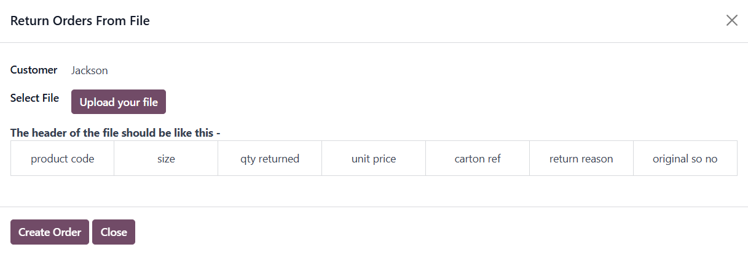

Enables creation of return sales orders by uploading an Excel file.

Process:

* Select customers.
* Upload the Excel file.

# **Excel File Format**

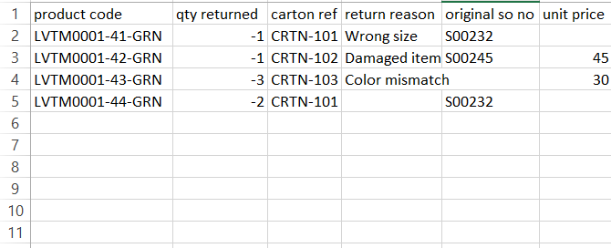

**Required Columns**:

* product code: Product Name.
* qty returned: Quantity of the product (must be **negative**).

**Optional Columns**:

* carton ref: Carton reference number.
* return reason: Reason for return.
* original so no: Original sales order number.
* unit price:
  + If manually entered, the unit price will be used as the manually entered price.
  + If left blank, the system uses the product’s **standard price**.

### 